K L UNIVERSITY
FRESHMAN ENGINEERING DEPARTMENT

A Project Based Lab Report On

EMI MASTER – LOAN CALCULATOR & PREPAYMENT SIMULATOR (EMIM-LCPS)

SUBMITTED BY:
ID NUMBER NAME
2500030352 V. ABHISHIKTA

UNDER THE ESTEEMED GUIDANCE OF Dr. N. SREE RAM
ASSISTANT PROFESSOR



KL UNIVERSITY
Green fields, Vaddeswaram – 522 502 Guntur Dt., AP, India.

DEPARTMENT OF BASIC ENGINEERING SCIENCES



CERTIFICATE

This is to certify that the project based laboratory report entitled ”EMI MASTER – LOAN CALCULATOR & PREPAYMENT SIMULATOR (EMIM-LCPS)”submitted by V.ABHISHIKTHA bearing Regd. No. 2500030352 to the Department of COMPUTER SICENCE ENGINEERING , KL University in partial fulfillment of the requirements for the completion of a project based Laboratory in “Python Programming (25SC2007)” course in I B Tech II Semester, is a Bonafede record of the work carried out by him/her under my supervision during the academic year 2025 – 2026.

PROJECT SUPERVISOR HEAD OF THE DEPARTMENT Dr. N. SREE RAM Dr. D. HARITHA

ACKNOWLEDGEMENTS

It gives us immense pleasure to express our sincere gratitude to our Honourable President, Sri. Koneru Satyanarayana, for providing us with the excellent academic environment and facilities to complete this project successfully.

We express our heartfelt thanks to our respected Director Dr. A. Jagadeesh for his continuous encouragement and support towards our academic growth.

We are deeply thankful to our Coordinator and HOD, Department of Basic Engineering Sciences, Dr. D. HARITHA, for her valuable guidance, motivation, and leadership throughout the semester.

We would like to express our sincere gratitude to our respected project guide and faculty mentor
Dr. N. SREE RAM, for the constant support, valuable suggestions, and technical guidance provided during the development of our project “EMI MASTER – Loan Calculator & Prepayment Simulator (EMIM-LCPS)”.

We also thank all the faculty members, friends, and classmates who directly or indirectly helped us in completing this project successfully.
Finally, we are grateful to KL University for providing the resources, infrastructure, and platform to transform our ideas into a practical and useful project.

Name: V. ABHISHIKTHA
ID No: 2500030352

ABSTRACT

The EMI MASTER – Loan Calculator & Prepayment Simulator (EMIM-LCPS) is a smart financial utility project designed to simplify loan repayment calculations and improve financial planning. The main purpose of this system is to help users calculate the Equated Monthly Instalment (EMI) for different types of loans such as home loans, personal loans, vehicle loans, and education loans.

The application allows users to enter the loan amount, annual interest rate, and repayment tenure, and instantly generates the monthly EMI, total interest payable, and total repayment amount using the standard EMI formula. This reduces manual calculation effort and ensures high accuracy.
A key feature of this project is the prepayment simulator, which enables users to analyse the effect of making extra payments during the loan period. By entering a one-time or recurring prepayment amount, users can observe the reduction in loan tenure, interest savings, and revised repayment schedule. This feature helps users make informed decisions about early loan closure and better money management.
The project is implemented using programming concepts such as mathematical formulas, loops, conditional statements, and modular functions, making it a practical example of applying computational thinking to real-world financial problems.

This system is highly useful for students, professionals, and general users who want a quick and reliable way to estimate EMI and understand the benefits of loan prepayment.
Keywords: EMI, Loan Calculator, Prepayment, Interest Rate, Financial Planning, Simulator.

INDEX

S.NO | TITLE | PAGE NO
1 | Introduction | 6
2 | Aim of the Project | 7
2.1 | Advantages & Disadvantages | 8
2.2 | Future Implementation | 8
3 | Software & Hardware Details | 9
4 | Data Flow Diagram | 10-11
5 | Algorithm for each module | 12
6 | Implementation | 13-14
7 | Integration and System Testing | 15-16
8 | Conclusion | 17

INTRODUCTION
The EMI MASTER – Loan Calculator & Prepayment Simulator (EMIM-LCPS) is a finance-based application developed to help users calculate loan EMI quickly and accurately. EMI stands for Equated Monthly Instalment, which is the fixed amount paid every month by a borrower to repay a loan within a selected tenure.
In today’s world, loans such as home loans, personal loans, vehicle loans, and education loans are very common. Before taking a loan, it is important to know the monthly EMI, total interest, and total repayment amount. Manual calculation of these values can be difficult and may lead to mistakes. This project solves that problem by providing an automated EMI calculator.

The major highlight of this project is the Prepayment Simulator. This module allows users to enter an extra monthly payment or one-time lump sum payment and check how much interest can be saved and how many months can be reduced from the loan tenure.
This project is highly beneficial for:
- Students learning finance-based programming
- Individuals planning to take loans
- Families comparing loan options
- Professionals managing multiple EMIs
The project also demonstrates the practical use of:
- Mathematical formulas
- Loops
- Conditional statements
- Functions / modular programming
- User input handling
Overall, this system is a simple, user-friendly, and practical financial planning tool that helps users make better loan repayment decisions.
.

AIM

The main aim of the EMI MASTER – Loan Calculator & Prepayment Simulator (EMIM-LCPS) project is to develop a smart and user-friendly financial application that helps users calculate Equated Monthly Instalments (EMI) for different types of loans and analyse the benefits of loan prepayment.
The objectives of this project are:
- To calculate the monthly EMI based on loan amount, interest rate, and tenure
- To display the total interest payable and total repayment amount
- To simulate one-time and monthly prepayment options
- To show interest savings after prepayment
- To estimate the reduced loan tenure
- To help users make better financial planning decisions
- To reduce errors caused by manual EMI calculations
- To apply programming concepts to a real-world financial problem
The project mainly focuses on providing accurate calculations, quick results, and easy understanding of loan repayment strategies, making it useful for both educational and practical purposes.

ADVANTAGES

Fast EMI calculation

Accurate results

Shows total interest

Helps in prepayment planning

Reduces loan tenure

DISADVANTAGES
- Needs correct input values
- Supports mainly fixed interest rates
- No bank charges included
- No changing interest rate support

FUTURE IMPLEMENTATION

The project can be enhanced by adding bank comparison, graphical charts, and mobile app support for better financial planning.

SYSTEM REQUIREMENTS

SOFTWARE REQUIREMENTS:
The major software requirements of the project are as follows: Language: Python
Operating system: Windows 10 or above.
Technical requirements: Intel i3/i5 processor, 4 GB RAM, 500 MB storage, monitor, keyboard, mouse, and optional internet connection.

HARDWARE REQUIREMENTS:
The hardware requirements that map towards the software are as follows: RAM: 8 GB.
Processor: i5/i7
DATA FLOW DIAGRAM

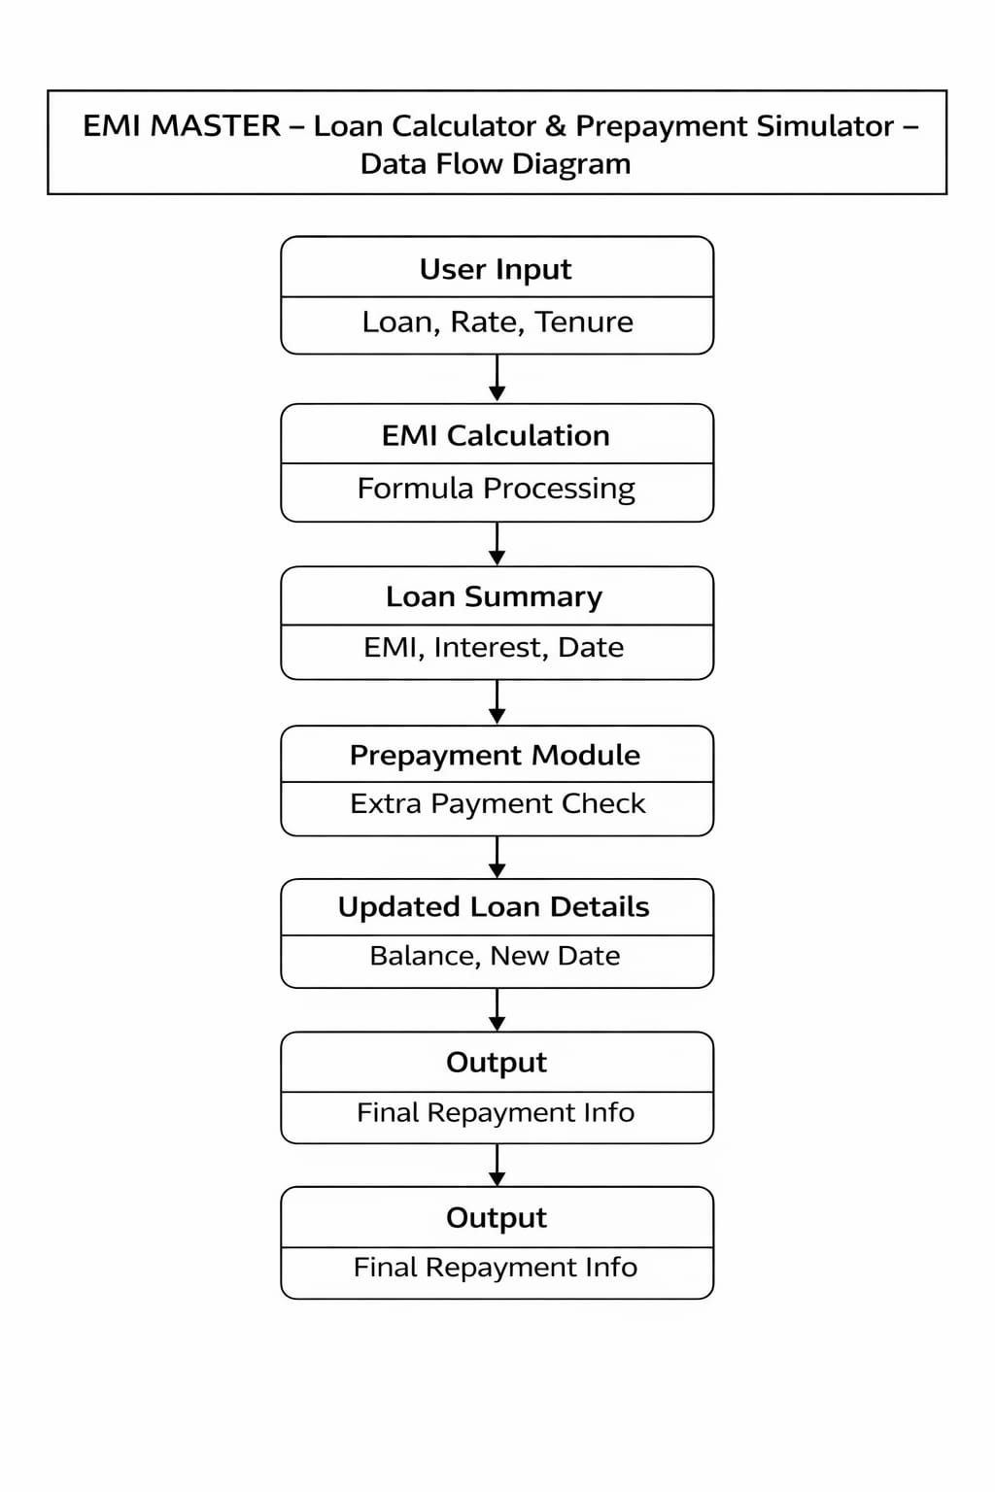

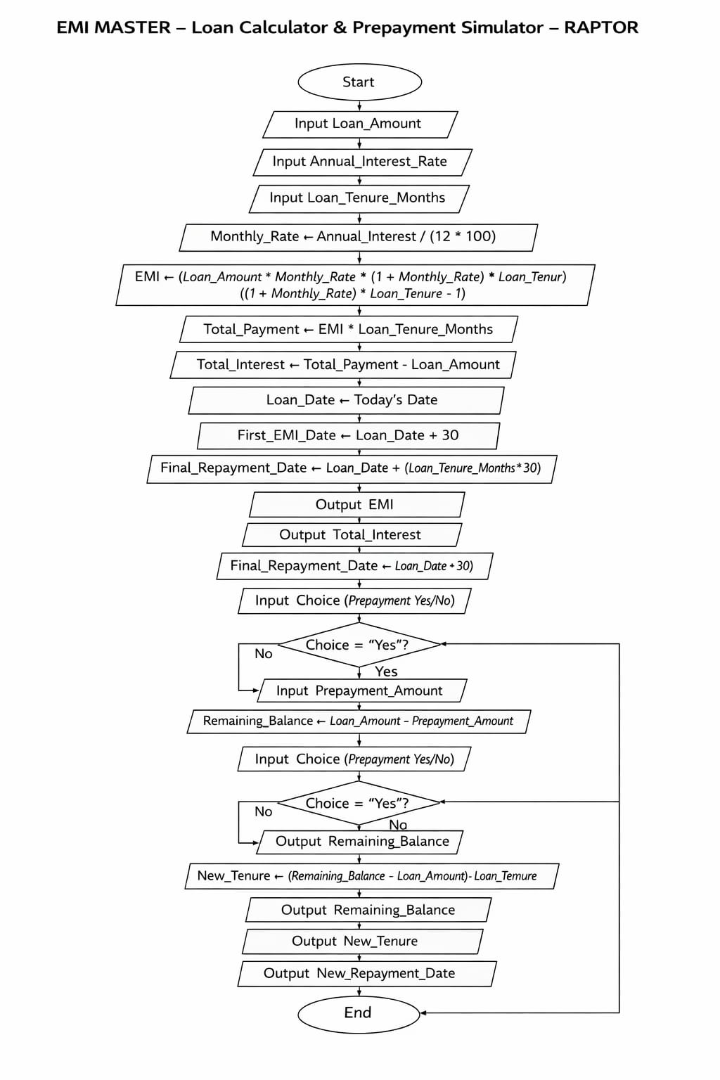

ALGORITHM

Step 1: Start
Step 2: Enter loan amount, annual interest rate, and loan tenure
Step 3: Convert annual interest rate into monthly interest rate
Step 4: Apply EMI formula to calculate monthly EMI
Step 5: Display EMI, total interest, and total repayment amount
Step 6: Ask user to enter prepayment amount
Step 7: Recalculate remaining balance and new tenure
Step 8: Display interest savings and reduced loan period
Step 9: Stop

IMPLEMENTATION
import math
from datetime import datetime, timedelta

# EMI calculation function
def Calculate_Emi(principal, annual_rate, tenure):
monthly_rate = annual_rate / (12 * 100)
emi = (principal * monthly_rate * math.pow(1 + monthly_rate, tenure)) / \
(math.pow(1 + monthly_rate, tenure) - 1)
return emi

# Display loan summary
def display_summary(principal, emi, tenure, loan_date):
total_payment = emi * tenure
total_interest = total_payment - principal

first_due_date = loan_date + timedelta(days=30)
final_date = loan_date + timedelta(days=tenure * 30)

print("\n========== LOAN SUMMARY ==========")
print(f"Loan Amount : ₹{principal:.2f}")
print(f"Monthly EMI : ₹{emi:.2f}")
print(f"Loan Tenure : {tenure} months")
print(f"Total Interest : ₹{total_interest:.2f}")
print(f"Total Repayment : ₹{total_payment:.2f}")
print(f"Loan Taken Date : {loan_date.strftime('%d-%m-%Y')}")
print(f"First EMI Due Date : {first_due_date.strftime('%d-%m-%Y')}")
print(f"Final Repayment Date: {final_date.strftime('%d-%m-%Y')}")
print("==================================")

# Prepayment simulation
def prepayment_simulator(principal, prepayment, tenure, loan_date):
new_balance = principal - prepayment

print("\n====== PREPAYMENT DETAILS ======")
print(f"Original Loan : ₹{principal:.2f}")
print(f"Prepayment Amount : ₹{prepayment:.2f}")

if new_balance <= 0:
print("Loan can be closed completely.")
else:
new_tenure = int((new_balance / principal) * tenure)
new_final_date = loan_date + timedelta(days=new_tenure * 30)

print(f"Remaining Balance : ₹{new_balance:.2f}")
print(f"Reduced Tenure : {new_tenure} months")
print(f"New Repayment Date : {new_final_date.strftime('%d-%m-%Y')}")

print("================================")

# Main program
try:
print("===== EMI MASTER =====")

principal = float(input("Enter Loan Amount: "))
annual_rate = float(input("Enter Annual Interest Rate (%): "))
tenure = int(input("Enter Loan Tenure (months): "))

if principal <= 0 or annual_rate <= 0 or tenure <= 0:
raise ValueError("All values must be greater than zero.")

# Automatically use today's date
loan_date = datetime.today()

emi = calculate_emi(principal, annual_rate, tenure)
display_summary(principal, emi, tenure, loan_date)

choice = input("\nDo you want to simulate prepayment? (yes/no): ").lower()

if choice == "yes":
prepayment = float(input("Enter Prepayment Amount: "))

if prepayment < 0:
raise ValueError("Prepayment cannot be negative.")

prepayment_simulator(principal, prepayment, tenure, loan_date)

print("\nThank you for using EMI MASTER!")

except ValueError as ve:
print("Input Error:", ve)

except ZeroDivisionError:
print("Math Error: Invalid interest rate.")

except Exception as e:
print("Unexpected Error:", e)

INTEGRATION AND SYSTEM TESTING
OUTPUTS

Screen Shots:

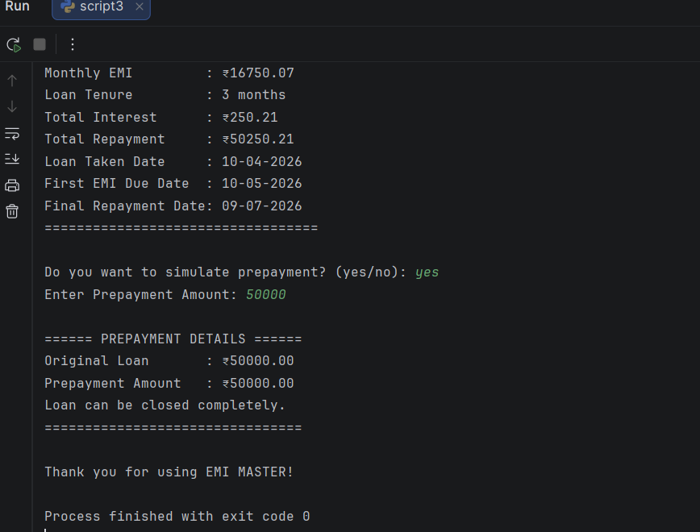
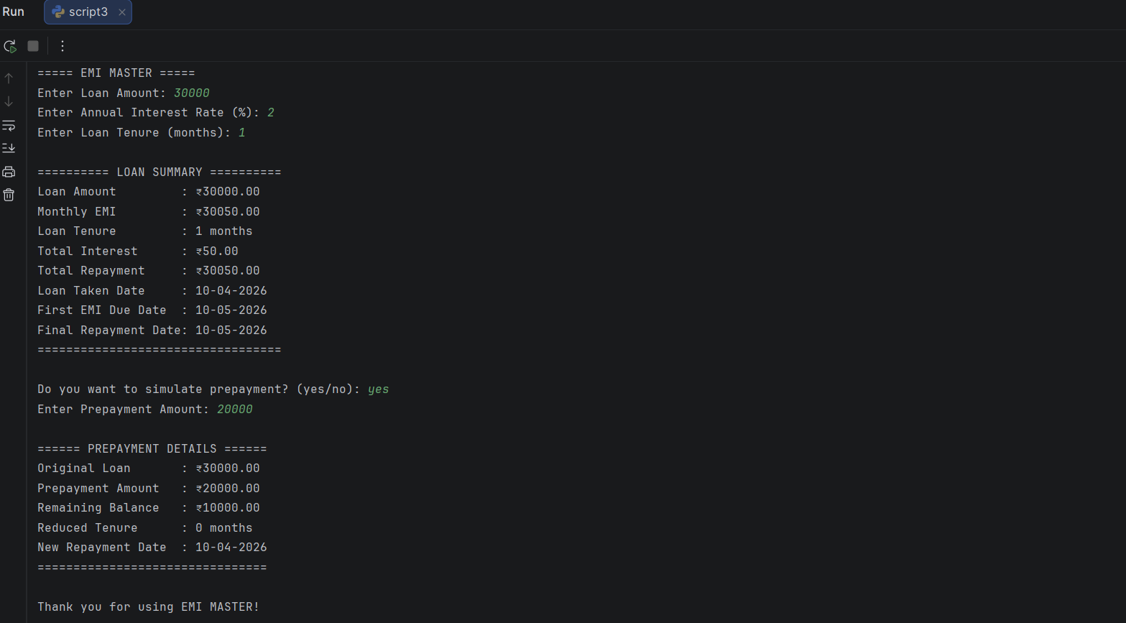
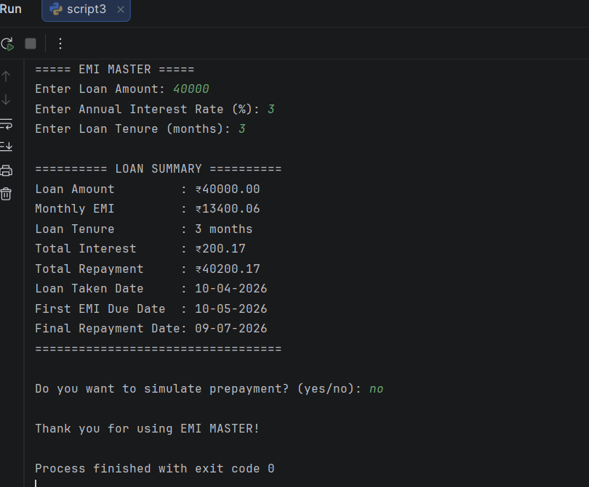

CONCLUSION
The EMI MASTER – Loan Calculator & Prepayment Simulator (EMIM-LCPS) project was successfully designed and implemented to simplify loan EMI calculations and repayment planning. The system accurately calculates the monthly EMI, total interest, and total repayment amount based on the user’s loan details.
The added prepayment simulation feature helps users understand how extra payments can reduce the loan tenure and repayment date, making financial planning easier and more effective. The system also automatically uses the current date as the loan taken date and predicts the first EMI due date and final repayment date, which makes the project more practical and user-friendly.
Overall, this project demonstrates the real-world application of programming, mathematical formulas, exception handling, date handling, and financial logic, making it highly useful for educational as well as practical purposes.

17

